**For Classification:**

| **Metric** | **Measures** | **In Scikit-learn** |
| --- | --- | --- |
| Precision | How many selected are relevant? | from sklearn.metrics import precision_score |
| Recall | How many relevant were selected? | from sklearn.metrics import recall_score |
| F1 | Weighted average of precision & recall | from sklearn.metrics import f1_score |
| Confusion Matrix | True positives, true negatives, false positives, false negatives | from sklearn.metrics import confusion_matrix |
| ROC | True positive rate vs. false positive rate, as classification threshold varies | from sklearn.metrics import roc |
| AUC | Aggregate accuracy, as classification threshold varies | from sklearn.metrics import auc |

**For Regression:**

| **Metric** | **Measures** | **In Scikit-learn** |
| --- | --- | --- |
| Mean Square Error (MSE, RMSE) | distance between predicted values and actual values (more sensitive to outliers) | from sklearn.metrics import mean_squared_error |
| Absolute Error (MAE, RAE) | distance between predicted values and actual values (less sensitive to outliers) | from sklearn.metrics import mean_absolute_error, median_absolute_error |
| Coefficient of Determination (R-Squared) | % of variance explained by the regression; how well future samples are likely to be predicted by the model | from sklearn.metrics import r2_score |

7 Important Model Evaluation Error Metrics Everyone should know

1. Confusion Matrix
2. Gain and Lift Chart
3. Kolmogorov Smirnov Chart
4. AUC – ROC
5. Gini Coefficient
6. Concordant – Discordant Ratio
7. Root Mean Squared Error
8. Cross Validation (Not a metric though!)

https://www.analyticsvidhya.com/blog/2016/02/7-important-model-evaluation-error-metrics/

## **Warming up: Types of Predictive models**

When we talk about predictive models, we are talking either about a regression model (continuous output) or a classification model (nominal or binary output). The evaluation metrics used in each of these models are different.

In classification problems, we use two types of algorithms (dependent on the kind of output it creates):

1. **Class output** : Algorithms like SVM and KNN create a class output. For instance, in a binary classification problem, the outputs will be either 0 or 1. However, today we have algorithms which can convert these class outputs to probability. But these algorithms are not well accepted by the statistics community.
2. **Probability output** : Algorithms like Logistic Regression, Random Forest, Gradient Boosting, Adaboost etc. give probability outputs. Converting probability outputs to class output is just a matter of creating a threshold probability.

In regression problems, we do not have such inconsistencies in output. The output is always continuous in nature and requires no further treatment.

**Illustrative Example**

For classification model evaluation metric discussion, I have used my predictions for the problem BCI challenge on Kaggle ([link](https://www.kaggle.com/c/inria-bci-challenge)) . The solution of the problem is irrelevant for the discussion, however the final predictions on the training set has been used for this article. The predictions made for this problem were probability outputs which have been converted to class outputs assuming a threshold of 0.5 .

## **1. Confusion Matrix**

A confusion matrix is an N X N matrix, where N is the number of classes being predicted. For the problem in hand, we have N=2, and hence we get a 2 X 2 matrix. Here are a few definitions, you need to remember for a confusion matrix :

* **Accuracy**: the proportion of the total number of predictions that were correct.
* **Positive Predictive Value or Precision**: the proportion of positive cases that were correctly identified.
* **Negative Predictive Value** : the proportion of negative cases that were correctly identified.
* **Sensitivity or Recall**: the proportion of actual positive cases which are correctly identified.
* **Specificity**: the proportion of actual negative cases which are correctly identified.

[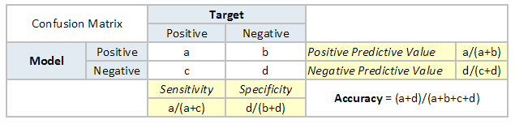](https://www.analyticsvidhya.com/blog/wp-content/uploads/2015/01/Confusion_matrix.png)

[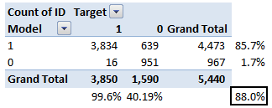](https://www.analyticsvidhya.com/blog/wp-content/uploads/2015/01/Confusion_matrix1.png)

The accuracy for the problem in hand comes out to be 88%.  As you can see from the above two tables, the Positive predictive Value is high, but negative predictive value is quite low. Same holds for Senstivity and Specificity. This is primarily driven by the threshold value we have chosen. If we decrease our threshold value, the two pairs of starkly different numbers will come closer.

In general we are concerned with one of the above defined metric. For instance, in a pharmaceutical company, they will be more concerned with minimal wrong positive diagnosis. Hence, they will be more concerned about high Specificity. On the other hand an attrition model will be more concerned with Senstivity.Confusion matrix are generally used only with class output models.

## **2. Gain and Lift charts**

Gain and Lift chart are mainly concerned to check the rank ordering of the probabilities. Here are the steps to build a Lift/Gain chart:

Step 1 : Calculate probability for each observation

Step 2 : Rank these probabilities in decreasing order.

Step 3 : Build deciles with each group having almost 10% of the observations.

Step 4 : Calculate the response rate at each deciles for Good (Responders) ,Bad (Non-responders) and total.

You will get following table from which you need to plot Gain/Lift charts:

[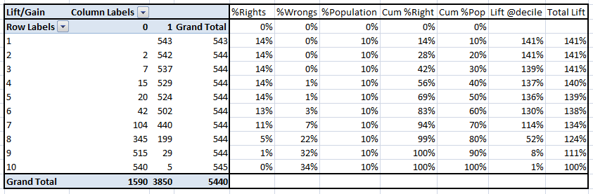](https://www.analyticsvidhya.com/blog/wp-content/uploads/2015/01/LiftnGain.png)

This is a very informative table. Cumulative Gain chart is the graph between Cumulative %Right and Cummulative %Population. For the case in hand here is the graph :

[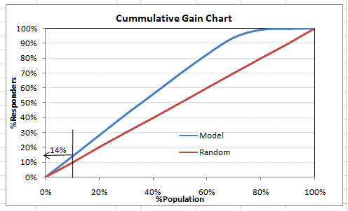](https://www.analyticsvidhya.com/blog/wp-content/uploads/2015/01/CumGain.png)

This graph tells you how well is your model segregating responders from non-responders. For example, the first decile however has 10% of the population, has 14% of responders. This means we have a 140% lift at first decile.

What is the maximum lift we could have reached in first decile? From the first table of this article, we know that the total number of responders are 3850. Also the first decile will contains 543 observations. Hence, the maximum lift at first decile could have been 543/3850 ~ 14.1%. Hence, we are quite close to perfection with this model.

Let’s now plot the lift curve. Lift curve is the plot between total lift and %population. Note that for a random model, this always stays flat at 100%. Here is the plot for the case in hand :

[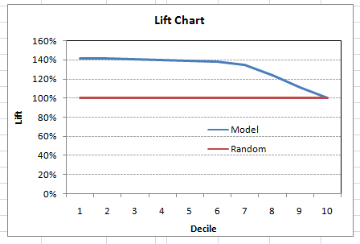](https://www.analyticsvidhya.com/blog/wp-content/uploads/2015/01/Lift.png)

You can also plot decile wise lift with decile number :

[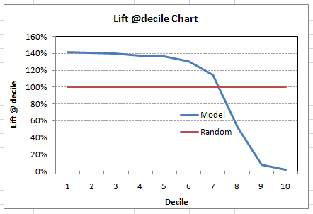](https://www.analyticsvidhya.com/blog/wp-content/uploads/2015/01/Liftdecile.png)

What does this graph tell you? It tells you that our model does well till the 7th decile. Post which every decile will be skewed towards non-responders. Any model with lift @ decile above 100% till minimum 3rd decile and maximum 7th decile is a good model. Else you might consider over sampling first.

Lift / Gain charts are widely used in campaign targeting problems. This tells us till which decile can we target customers for an specific campaign. Also, it tells you how much response do you expect from the new target base.

## **3. Kolomogorov Smirnov chart**

K-S or Kolmogorov-Smirnov chart measures performance of classification models. More accurately, K-S is a measure of the degree of separation between the positive and negative distributions. The K-S is 100, if the scores partition the population into two separate groups in which one group contains all the positives and the other all the negatives.

On the other hand, If the model cannot differentiate between positives and negatives, then it is as if the model selects cases randomly from the population. The K-S would be 0. In most classification models the K-S will fall between 0 and 100, and that the higher the value the better the model is at separating the positive from negative cases.

For the case in hand, following is the table :

[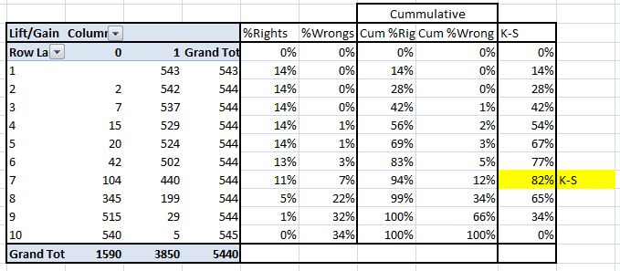](https://www.analyticsvidhya.com/blog/wp-content/uploads/2015/01/KS.png)

We can also plot the %Cumulative Good and Bad to see the maximum separation. Following is a sample plot :

[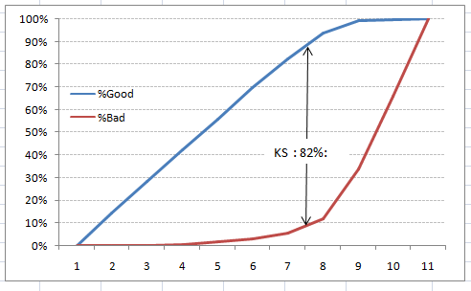](https://www.analyticsvidhya.com/blog/wp-content/uploads/2015/01/KS_plot.png)

The metrics covered till here are mostly used in classification problems. Till here, we learnt about confusion matrix, lift and gain chart and kolmogorov-smirnov chart. Let’s proceed and learn few more important metrics.

## **4. Area Under the ROC curve (AUC – ROC)**

This is again one of the popular metrics used in the industry.  The biggest advantage of using ROC curve is that it is independent of the change in proportion of responders. This statement will get clearer in the following sections.

Let’s first try to understand what is ROC (Receiver operating characteristic) curve. If we look at the confusion matrix below, we observe that for a probabilistic model, we get different value for each metric.

[](https://www.analyticsvidhya.com/blog/wp-content/uploads/2015/01/Confusion_matrix.png)

Hence, for each sensitivity, we get a different specificity.The two vary as follows:

[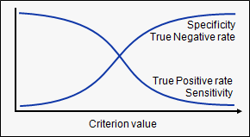](https://www.analyticsvidhya.com/blog/wp-content/uploads/2015/01/curves.png)

The ROC curve is the plot between sensitivity and (1- specificity). (1- specificity) is also known as false positive rate and sensitivity is also known as True Positive rate. Following is the ROC curve for the case in hand.

[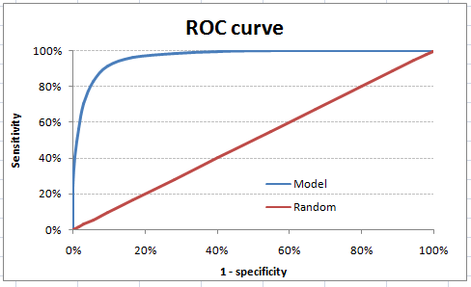](https://www.analyticsvidhya.com/blog/wp-content/uploads/2015/01/ROC.png)

Let’s take an example of threshold = 0.5 (refer to confusion matrix). Here is the confusion matrix :

[](https://www.analyticsvidhya.com/blog/wp-content/uploads/2015/01/Confusion_matrix2.png)

As you can see, the sensitivity at this threshold is 99.6% and the (1-specificity) is ~60%. This coordinate becomes on point in our ROC curve. To bring this curve down to a single number, we find the area under this curve (AUC).

Note that the area of entire square is 1*1 = 1. Hence AUC itself is the ratio under the curve and the total area. For the case in hand, we get AUC ROC as 96.4%. Following are a few thumb rules:

* .90-1 = excellent (A)
* .80-.90 = good (B)
* .70-.80 = fair (C)
* .60-.70 = poor (D)
* .50-.60 = fail (F)

We see that we fall under the excellent band for the current model. But this might simply be over-fitting. In such cases it becomes very important to to in-time and out-of-time validations.

**Points to Remember:**

1. For a model which gives class as output, will be represented as a single point in ROC plot.

2. Such models cannot be compared with each other as the judgement needs to be taken on a single metric and not using multiple metrics. For instance, model with parameters (0.2,0.8) and model with parameter (0.8,0.2) can be coming out of the same model, hence these metrics should not be directly compared.

3. In case of probabilistic model, we were fortunate enough to get a single number which was AUC-ROC. But still, we need to look at the entire curve to make conclusive decisions. It is also possible that one model performs better in some region and other performs better in other.

### **Advantages of using ROC**

Why should you use ROC and not metrics like lift curve?

Lift is dependent on total response rate of the population. Hence, if the response rate of the population changes, the same model will give a different lift chart. A solution to this concern can be true lift chart (finding the ratio of lift and perfect model lift at each decile). But such ratio rarely makes sense for the business.

ROC curve on the other hand is almost independent of the response rate. This is because it has the two axis coming out from columnar calculations of confusion matrix. The numerator and denominator of both x and y axis will change on similar scale in case of response rate shift.

## **5. Gini Coefficient**

Gini coefficient is sometimes used in classification problems. Gini coefficient can be straigh away derived from the AUC ROC number. Gini is nothing but ratio between area between the ROC curve and the diagnol line & the area of the above triangle. Following is the formulae used :

Gini = 2*AUC – 1

Gini above 60% is a good model. For the case in hand we get Gini as 92.7%.

## **6. Concordant – Discordant ratio**

This is again one of the most important metric for any classification predictions problem. To understand this let’s assume we have 3 students who have some likelihood to pass this year. Following are our predictions :

A – 0.9

B – 0.5

C – 0.3

Now picture this. if we were to fetch pairs of two from these three student, how many pairs will we have? We will have 3 pairs : AB , BC, CA. Now, after the year ends we saw that A and C passed this year while B failed. No, we choose all the pairs where we will find one responder and other non-responder. How many such pairs do we have?

We have two pairs AB and BC. Now for each of the 2 pairs, the concordant pair is where the probability of responder was higher than non-responder. Whereas discordant pair is where the vice-versa holds true. In case both the probabilities were equal, we say its a tie. Let’s see what happens in our case :

AB  – Concordant

BC – Discordant

Hence, we have 50% of concordant cases in this example. Concordant ratio of more than 60% is considered to be a good model. This metric generally is not used when deciding how many customer to target etc. It is primarily used to access the model’s predictive power. For decisions like how many to target are again taken by KS / Lift charts.

## **7. Root Mean Squared Error (RMSE)**

RMSE is the most popular evaluation metric used in regression problems. It follows an assumption that error are unbiased and follow a normal distribution. Here are the key points to consider on RMSE:

1. The power of ‘square root’  empowers this metric to show large number deviations.
2. The ‘squared’ nature of this metric helps to deliver more robust results which prevents cancelling the positive and negative error values. In other words, this metric aptly displays the plausible magnitude of error term.
3. It avoids the use of absolute error values which is highly undesirable in mathematical calculations.
4. When we have more samples, reconstructing the error distribution using RMSE is considered to be more reliable.
5. RMSE is highly affected by outlier values. Hence, make sure you’ve removed outliers from your data set prior to using this metric.
6. As compared to mean absolute error, RMSE gives higher weightage and punishes large errors.

RMSE metric is given by:

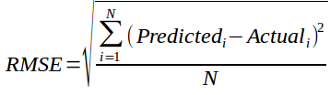

where, N is Total Number of Observations.

Beyond these 7 metrics, there is another method to check the model performance. These 7 methods are statistically prominent in data science. But, with arrival of machine learning, we are now blessed with more robut methods of model selection. **Yes! I’m talking about Cross Validation**.

Though, cross validation isn’t a really a evaluation metric which is used openly to communicate model accuracy. But, the result of cross validation provides good enough intuitive result to generalize the performance of a model.

Let’s now understand cross validation in detail.

## **8. Cross Validation**

Let’s first understand the importance of cross validation. Due to busy schedules, these days I don’t get much time to participate in data science competitions. Long time back, I participated in TFI Competition on Kaggle. Without delving into my competition performance, I would like to show you the dissimilarity between my public and private leaderboard score.

### **Here is an example of scoring on Kaggle!**

For TFI competition, following were three of my solution and scores (Lesser the better) :

[](https://www.analyticsvidhya.com/wp-content/uploads/2015/05/kagglescores.png)

You will notice that the third entry which has the worst Public score turned to be the best model on Private ranking. There were more than 20 models above the “submission_all.csv”, but I still chose “submission_all.csv” as my final entry (which really worked out well). What caused this phenomenon ? The dissimilarity in my public and private leaderboard is caused by over-fitting.

Over-fitting is nothing but when you model become highly complex that it starts capturing noise also. This ‘noise’ adds no value to model, but only inaccuracy.

In the following section, I will discuss how you can know if a solution is an over-fit or not before we actually know the test results.

### **The concept : Cross Validation**

Cross Validation is one of the most important concepts in any type of data modelling. It simply says, try to leave a sample on which you do not train the model and test the model on this sample before finalizing the model.

[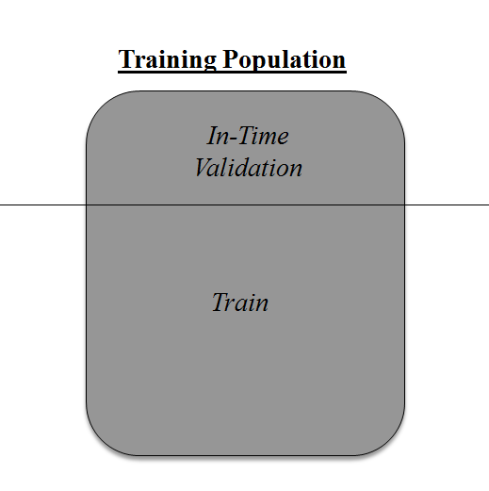](https://www.analyticsvidhya.com/wp-content/uploads/2015/05/validation.png)

Above diagram shows how to validate model with in-time sample. We simply divide the population into 2 samples, and build model on one sample. Rest of the population is used for in-time validation.

Could there be a negative side of the above approach?

I believe, a negative side of this approach is that we loose a good amount of data from training the model. Hence, the model is very high bias. And this won’t give best estimate for the coefficients. So what’s the next best option?

What if, we make a 50:50 split of training population and the train on first 50 and validate on rest 50. Then, we train on the other 50, test on first 50. This way we train the model on the entire population, however on 50% in one go. This reduces bias because of sample selection to some extent but gives a smaller sample to train the model on. This approach is known as 2-fold cross validation.

### **k-fold Cross validation**

Let’s extrapolate the last example to k-fold from 2-fold cross validation. Now, we will try to visualize how does a k-fold validation work.

[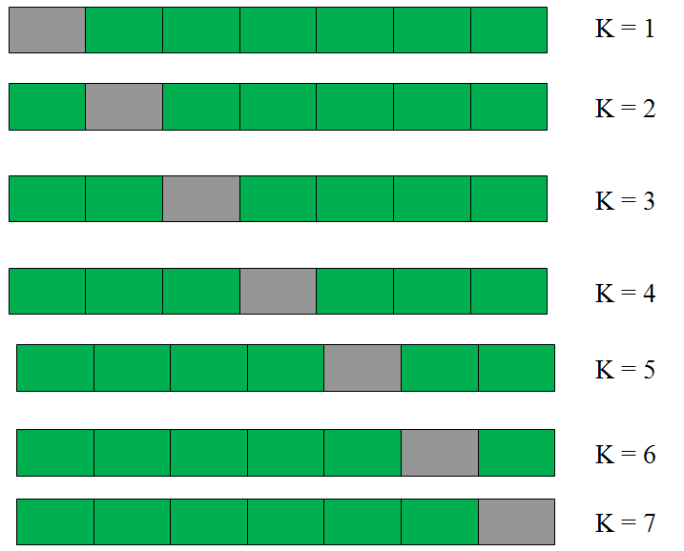](https://www.analyticsvidhya.com/wp-content/uploads/2015/05/kfolds.png)

This is a 7-fold cross validation.

Here’s what goes on behind the scene : we divide the entire population into 7 equal samples. Now we train models on 6 samples (Green boxes) and validate on 1 sample (grey box). Then, at the second iteration we train the model with a different sample held as validation. In 7 iterations, we have basically built model on each sample and held each of them as validation. This is a way to reduce the selection bias and reduce the variance in prediction power. Once we have all the 7 models, we take average of the error terms to find which of the models is best.

### **How does this help to find best (non over-fit) model?**

k-fold cross validation is widely used to check whether a model is an overfit or not. If the performance metrics at each of the k times modelling are close to each other and the mean of metric is highest. In a Kaggle competition, you might rely more on the cross validation score and not on the Kaggle public score. This way you will be sure that the Public score is not just by chance.

### **How do we implement k-fold with any model?**

Coding k-fold in R and Python are very similar. Here is how you code a k-fold in Python :

from sklearn import cross_validation model = RandomForestClassifier(n_estimators=100)

#Simple K-Fold cross validation. 5 folds.

#(Note: in older scikit-learn versions the "n_folds" argument is named "k".)

cv = cross_validation.KFold(len(train), n_folds=5, indices=False)

results = []

# "model" can be replaced by your model object # "Error_function" can be replaced by the error function of your analysis

for traincv, testcv in cv:

            probas = model.fit(train[traincv], target[traincv]).predict_proba(train[testcv])

            results.append( Error_function )

print out the mean of the cross-validated results

print "Results: " + str( np.array(results).mean() )

### **But how do we choose k?**

This is the tricky part. We have a trade off to choose k.

For a small k, we have a higher selection bias but low variance in the performances.

For a large k, we have a small selection bias but high variance in the performances.

Think of extreme cases :

k = 2  : We have only 2 samples similar to our 50-50 example. Here we build model only on 50% of the population each time. But as the validation is a significant population, the variance of validation performance is minimal.

k = number of observations (n) :  This is also known as “Leave one out”. We have n samples and modelling repeated n number of times leaving only one observation out for cross validation. Hence, the selection bias is minimal but the variance of validation performance is very large.

Generally a value of k = 10 is recommended for most purpose.